How water can affect plants

There are plants around us everywhere, but have you ever wondered how water can affect plants? If you have wondered about it, then read this explanation as it’s about how water can affect plants.

How can water affect the plants?
Water can affect plants in different ways. If the plant’s soil gets too much water, it can rot the plant’s roots and the plants then cant’ get enough oxygen from the soil. If plants don’t get enough water, the plans can’t get nutrients and they may die.

A plant can’t grow if it doesn’t have healthy roots then the plant can’t live. So watering is the key when growing plants.

How does water help a plant?
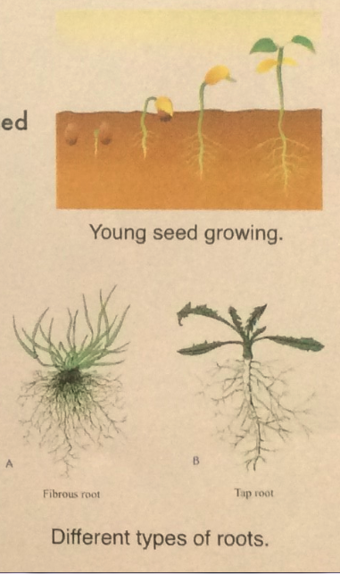
Water helps plants by transporting important nutrients through the plant. Nutrients are found in the soil and are used by the plant.

Water carries the sugar and other nutrients through the plant. So without the proper balance of water, it can get weaker and then it won’t be able to support its own weight.

About plant roots
The beginning of the roots are found in the embryo within the seed. It is called a radicle and will eventually form the primary root of a young plant. The primary roots will turn into one of the two main types of roots in plants: a taproot or a fibrous root. The roots help the plants to stand up and given them the nutrients from the soil.

Tips
With your own plants, there are a few simple ways to check if the soil has enough water. One of the quickest ways to check is to just dig your fingers in the soil next to your plant (but not too close to the plant because you can damage the plant’s roots) up to your knuckle and if it’s wet, then it has enough water, but if it’s dry, then it doesn’t have enough water.

So remember to water the plants, but not too much water.

